Temperature Prediction

abstract
This temperature prediction project leverages historical temperature data from cities, countries, and global temperatures to address climate change, global warming, and weather forecasting. Employing machine learning and statistical time series analysis, the project predicts temperature trends, affecting sectors like energy management, agriculture, public health, and more. Analysis spans individual cities, entire countries, major global cities, and global temperatures, with methodologies including traditional statistical analysis, ARIMA modeling, and advanced techniques like XGBoost and LightGBM. The standout performer is the LSTM neural network model, particularly effective at capturing local temperature dynamics. Applications extend to daily planning, industries, energy management, agriculture, public health, environmental monitoring, infrastructure development, travel, retail, and disaster preparedness. The project's predictions inform decision-making, emphasizing the importance of proactive measures in addressing climate change challenges.

Problem Statement
The escalating challenge of global warming, with its complex impacts on ecosystems, economies, and public health, necessitates advanced predictive models to accurately forecast temperature fluctuations. This temperature prediction project aims to tackle the intricacies of climate change by developing robust machine learning models capable of analyzing historical temperature data across various geographies. The goal is to provide precise and actionable temperature forecasts to inform decision-making in sectors like agriculture, energy, and urban planning. Addressing this problem is vital for devising effective strategies to mitigate the adverse effects of climate change and ensure sustainable development in the face of rising global temperatures.

introduction
Climate change, particularly global warming, poses pivotal challenges with profound impacts on ecosystems, societies, and economies. This project focuses on developing accurate temperature prediction models using historical data from cities, countries, and global temperatures. The primary objective is to understand intricate temperature variations over time and provide insights into global warming trends. Employing analytical tools and machine learning, the project explores temperature dynamics at various scales, contributing to a comprehensive understanding of climate patterns.
The project's significance extends to mapping temperature predictions with agricultural data, highlighting the critical relationship between climate forecasts and food security. By accurately predicting temperature fluctuations, the project aims to assess the potential impact on agricultural productivity and food supply chains. This information is crucial for policymakers, agricultural stakeholders, and food security advocates, as it enables proactive planning and adaptation strategies to ensure food security in the face of changing climatic conditions.
Accurate temperature predictions have far-reaching implications, influencing sectors like energy management, agriculture planning, public health, and disaster preparedness. The integration of advanced machine learning models, including Long Short-Term Memory (LSTM) networks, enhances prediction precision, offering valuable information for decision-makers across industries. As today's world grapples with climate change challenges, this project provides future knowledge about temperature trends, aiming to inform decision-making and proactive measures to address urgent climate issues.

Literature Survey/Related Works
- Accurate long-term air temperature prediction with Machine Learning models and data reduction techniques [1].
Summary: The paper introduces three AI frameworks for long-term air temperature prediction in Paris and Córdoba, demonstrating high accuracy. It aligns with the proposed research's goal of developing temperature prediction models, offering valuable insights.
Relationship to Proposed Research: The paper's AI frameworks and methodologies provide relevant insights for enhancing the precision of the proposed research's temperature prediction models.
- The Vulnerability of Global Cities to Climate Hazards [2]
Summary: This paper tests an extended vulnerability framework on three coastal cities facing climate hazards, revealing nuanced vulnerabilities. The framework, while requiring refinement, proves valuable for guiding assessments.
Relationship to Proposed Research: Aligning with our research, this holistic vulnerability approach informs our AI-based climate prediction models, enhancing accuracy and relevance.
- Assessing the Impact of Extreme Temperature Conditions on Social Vulnerability
Summary: This research refines Romania's vulnerability assessment methodology, pinpointing key factors in Cluj County's vulnerability, such as adaptive capacity and poverty.
Relationship to Proposed Research: Aligning with our goals, this study contributes insights to vulnerability assessments, emphasizing key drivers. The CleSoVI index's spatial analysis guides local interventions, reinforcing our AI-based climate prediction models.

Material and Method or Methodology
- Data Collection
The foundation of this project lies in the utilization of comprehensive datasets containing historical temperature records and agricultural data. Historical temperature data are sourced from various sources, including cities, countries, major global cities, and global temperatures, providing a rich repository for temperature analysis. Additionally, agricultural data crucial for understanding the impact of temperature predictions on crop yield and food security are obtained from the "Crop Yield Prediction Dataset" available on Kaggle. This dataset includes factors such as weather conditions (rain, temperature, etc.), pesticides, and accurate information about the history of crop yield, essential for making decisions related to agricultural risk management and future predictions.
- Data Preprocessing
Upon importing the dataset using the Pandas library in Python, an initial exploration is conducted to understand the structure and characteristics of the data. Descriptive statistics, such as mean, standard deviation, and quantiles, are computed to gain insights into the temperature distribution. The dataset is thoroughly examined for missing values, and appropriate measures, such as dropping or imputing missing data, are taken to ensure data integrity.
- Temporal Feature Engineering
To enhance the temporal analysis, the "dt" column, representing the date, is converted to a datetime format. Additional temporal features, including Month, Day, Weekday, and Year, are extracted from the date information. These features enable a granular exploration of temperature variations over different time scales, facilitating the identification of long-term trends and seasonal patterns.
- Exploratory Data Analysis (EDA):
Exploratory Data Analysis is employed to visualize and understand temperature trends at various levels, including individual cities and global temperatures. Seaborn and Matplotlib libraries are utilized for creating informative visualizations, such as scatter plots, line plots, and regression plots. Specific attention is given to ten selected cities, including Madrid, Berlin, London, Saint Petersburg, Rome, and Moscow, to showcase localized temperature dynamics.
- Statistical Time Series Analysis
Statistical time series analysis is conducted to uncover underlying patterns in the temperature data. Autocorrelation Function (ACF) and Partial Autocorrelation Function (PACF) plots are generated to assess temporal dependencies. Augmented Dickey-Fuller tests are employed to evaluate the stationarity of the time series, ensuring the reliability of subsequent time series modeling approaches.
- Machine Learning Models
The project employs a diverse set of machine learning models for temperature prediction at different spatial scales. Linear Regression models are utilized for their simplicity and interpretability, while advanced ensemble models such as XGBoost and LightGBM are employed for enhanced predictive accuracy. The standout performer, a Long Short-Term Memory (LSTM) neural network, is applied to capture complex temporal dependencies in the temperature data.
- Model Evaluation
The performance of each model is evaluated using metrics such as Mean Squared Error (MSE) to quantify the accuracy of temperature predictions. Model evaluation is conducted on both training and testing datasets to ensure the generalizability of the models. In the case of time series models, the evaluation includes visual comparisons of predicted and actual temperature trends over time.
- Future Predictions
In addition to historical temperature analysis, the LSTM model is utilized to generate future temperature predictions. Sequences of temperature data are fed into the trained model to forecast temperature values beyond the observed timeframe. The results are visualized to provide insights into potential future temperature trends, allowing for proactive planning and decision-making.
The combination of data preprocessing, exploratory data analysis, statistical time series analysis, and machine learning modeling techniques forms a robust methodology for understanding and predicting temperature patterns. This approach enables valuable insights into climate change dynamics and their implications for various sectors, offering a foundation for informed decision-making and proactive planning.

Experimental Setup
Data Preparation
Data Splitting: Historical temperature data were partitioned into training and testing sets, adhering to a 70:30 ratio. This division ensured that the models had a substantial amount of data to learn from while retaining a separate portion for unbiased evaluation.
Feature Processing: Temporal features were extracted from the date column and normalized to ensure uniformity in scale, which is crucial for models like Linear Regression and LSTM that are sensitive to feature magnitude.
Model Training and Tuning
Initial Training: Each model, including Linear Regression, ARIMA, XGBoost, LightGBM, and LSTM, was initially trained with default parameters to establish baseline performance metrics.
Hyperparameter Tuning: Using grid search and cross-validation, we iteratively adjusted parameters such as the learning rate for gradient boosting models and the number of hidden layers and units in LSTM. This process aimed to find the optimal model configuration that minimized prediction errors.
Model Optimization: Special attention was given to the LSTM model, where the sequence length and batch size were fine-tuned to improve its ability to capture long-term temporal dependencies in the temperature data.
Model Evaluation
Performance Metrics: The predictive accuracy of each model was quantified using Mean Squared Error (MSE) and Root Mean Squared Error (RMSE), providing a clear measure of how closely the models' predictions matched the actual temperature records.
Validation Strategy: Cross-validation techniques were employed to assess model stability and avoid overfitting, ensuring that the performance metrics were robust and representative of the models' true predictive capabilities.
Future Predictions
Forecasting: Utilizing the tuned LSTM model, we projected future temperature trends by feeding the most recent temperature data into the model. This predictive exercise aimed to simulate potential climate change scenarios and understand the temporal dynamics of temperature variations.
Analysis of Predictions: The forecasted temperature data were then analyzed to identify significant patterns and anomalies, providing insights into potential future climatic conditions and facilitating informed decision-making for climate-related challenges.
This experimental setup, with a detailed approach to data handling, model training, and evaluation, ensured a comprehensive analysis of temperature trends and furnished reliable predictive models capable of simulating future climate scenarios.

Results and Analysis
Time Series Analysis
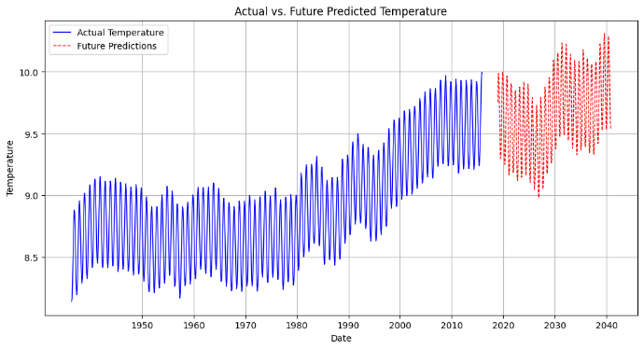
Fig. Global Temperatures
In Global Temperatures, we observe a detailed time series analysis of temperature data with actual recorded temperatures shown in blue and the LSTM model's future predictions in red. The plot shows the temperature variability throughout the years with a clear increasing trend. As we move into the future predictions, there is a noticeable uncertainty represented by the widening of the prediction intervals, reflecting the inherent challenges in long-term climate forecasting.

State-Level Details
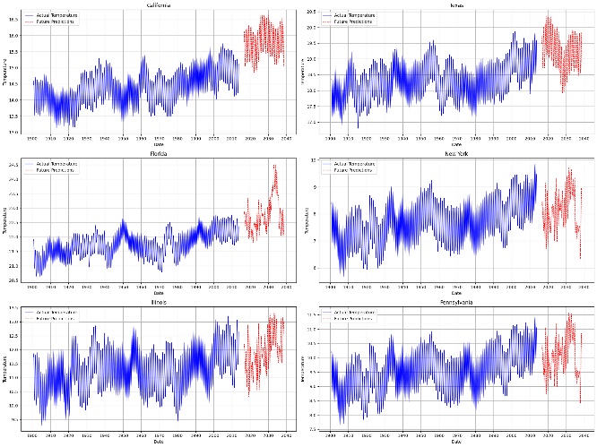
Fig. Global Land Temperatures by State
The plots within Global Land Temperatures By State break down temperature trends at the state level for specific regions such as California, Texas, and New York. Each plot demonstrates unique climatic characteristics and trends of the individual states. California's temperature, for example, exhibits a marked upward trend, consistent with the global warming narrative, while Texas shows greater inter-annual variability, perhaps due to its diverse climatic zones.

Major City Focus
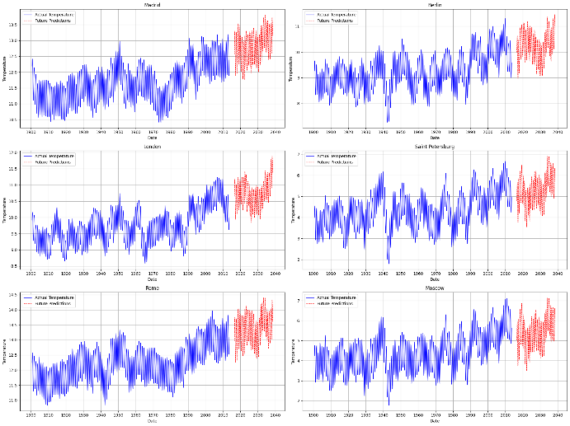
Fig. Global Land Temperature by Major City
Moving to a more urban perspective, Global Land Temperature By Major City reflects the temperature changes within major global cities. These urban areas often experience the heat island effect, which may exacerbate the warming trend. The actual versus predicted temperature lines for cities like Cairo and Sydney illustrate the urban heat influence with higher temperature predictions for the coming years.

Country-Wide Overview
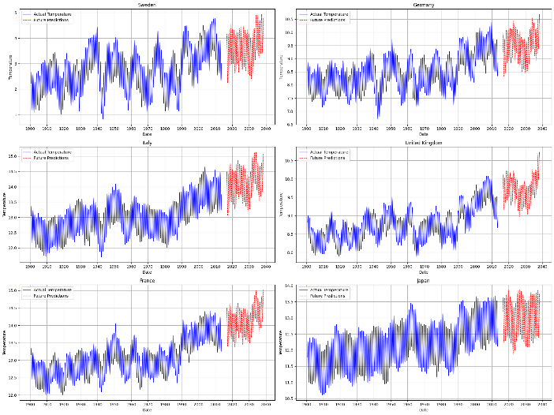
Fig. Global Land Temperatures by Country
Global Land Temperatures By Country gives a broader view at the country level. It highlights the disparity between different countries' temperature trends, which can be influenced by geographical location, altitude, and local climate conditions. For example, the temperature increase in Sweden is less steep compared to more equatorial regions, indicating a variation in how climate change affects different latitudes.

City-Specific Trends
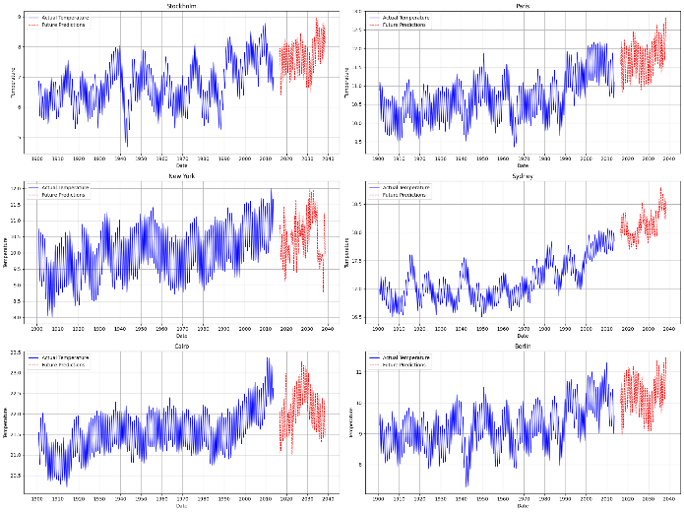
Fig. Global Land Temperatures by City
In Global Land Temperatures By City, a granular look at specific cities such as Stockholm, Paris, and Berlin allows us to correlate local urban development and geographical features with temperature trends. The prediction plots suggest that northern hemisphere cities will continue to experience rising temperatures, although with different rates of change.

Heatmaps
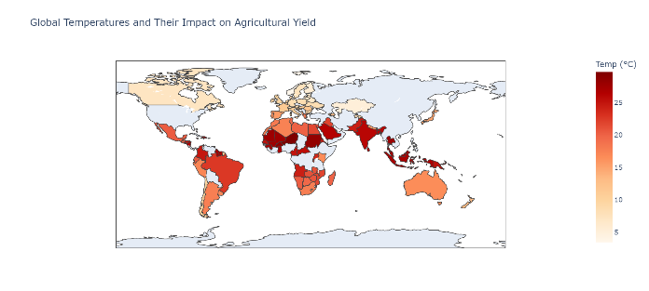
Fig. Global Temperatures and Their Impact on Agricultural Yield
The heatmap, "Global Temperatures and Their Impact on Agricultural Yield", uses a color gradient to illustrate how varying temperatures may affect agriculture, with warmer regions potentially facing greater challenges.
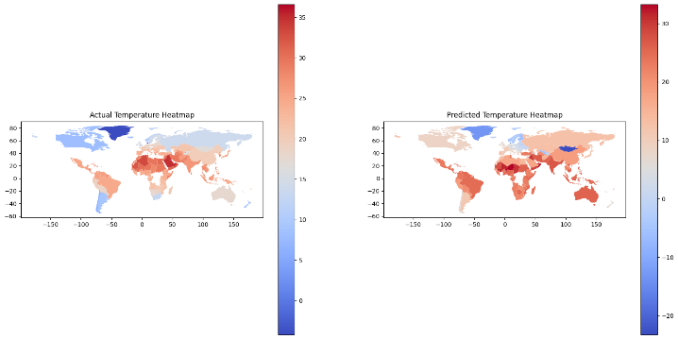
"Actual vs. Predicted Temperature Heatmap", contrasts observed temperatures with forecasted data, showing real conditions against predictions, which is useful for evaluating the accuracy of climate models.

Synthesis and Future Directions
Combining the insights from the different plots, we see a consistent signal of warming across various scales, from local cities to global trends. The detailed predictions offer valuable information for policymakers, urban planners, and environmental scientists, suggesting a clear need for adaptive strategies to mitigate the effects of rising temperatures. Future models may incorporate more variables such as CO2 emissions, deforestation rates, and ocean temperature patterns to improve prediction accuracy.
.

Conclusion & Future Scope
Conclusion
In conclusion, this temperature prediction project has laid a solid foundation for understanding temperature trends and their implications on agricultural productivity. By incorporating historical temperature data and agricultural information, the project has enabled the prediction of not only temperature fluctuations but also agricultural products production. The interplay between temperature variations and agricultural output is crucial for addressing food security challenges in the face of climate change.
The project's findings suggest a direct correlation between rising temperatures and potential impacts on crop yields and food supply chains. As temperatures continue to rise globally, proactive measures must be implemented to mitigate these adverse effects and ensure sustainable food production. By leveraging machine learning models and predictive analytics, stakeholders can make informed decisions to adapt agricultural practices, optimize resource allocation, and enhance resilience against climate-related risks.

Future Scope
The project's future scope involves leveraging the dual predictions of temperature and agricultural products production to devise strategic plans for climate adaptation and food security. Utilizing advanced machine learning techniques, such as ensemble models and deep learning algorithms, the project can enhance the accuracy and granularity of temperature and crop yield predictions. This refined forecasting capability enables policymakers, agricultural stakeholders, and food security advocates to proactively plan and implement adaptive strategies.
Moreover, integrating real-time environmental data, satellite imagery, and IoT sensors with predictive models can provide continuous monitoring and early warning systems for climate-related impacts on agriculture. This holistic approach not only improves prediction accuracy but also enables dynamic decision-making and resource management in response to changing climatic conditions.
The project's outcomes and future advancements offer valuable insights and tools for sustainable agricultural practices, climate-resilient food systems, and long-term food security planning. By harnessing the power of data-driven analytics and predictive modeling, we can navigate the challenges of climate change while ensuring a stable and secure food supply for future generations.

authors contribution
The paper is solely written by myself along with all the research and paper.

References
[1] D. Fister, J. Pérez-Aracil, C. Peláez-Rodríguez, J. Del Ser, S. Salcedo-Sanz, Department of Signal Processing and Communications, Universidad de Alcalá, 28805, Madrid, Spain TECNALIA, Basque Research & Technology Alliance (BRTA), 48160 Derio, Spain
University of the Basque Country (UPV/EHU), 48013 Bilbao, Spain
[2] A. Schiller is with the George Perkins Marsh Institute, Clark University, Worcester, MA 01610, USAA. de Sherbinin is with the Center for International Earth Science Information Network (CIESIN), Columbia University, Palisades, NY 10964, USA.
[3] I. Török, A.-E. Croitoru, and T.-C. Man, "Assessing the Impact of Extreme Temperature Conditions on Social Vulnerability," Sustainability, vol. 13, pp. 8510, 2021. [Online]. Available: https://doi.org/10.3390/su1

